**CRACK THE COVID-19 CRISIS**

**BY**

[**NASSCOM FUTURESKILLS AND IBM**](https://beatest.in/challenge/3)

**Team Name:**SHIKSHA

**Title of the project:**e-svadhyaya

**SOLUTION ARCHITECTURE**

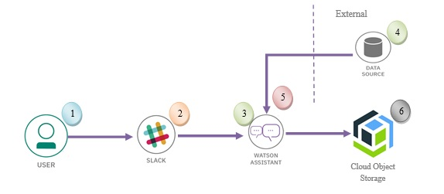

**Team Members:**

1. N. Lalitha Madhulika
2. N. Mounica
3. C.Sri Harshitha
4. M.Rudra Sai Prasad
5. S.Shubham

**Team Mentor:**

Dr.Ch.Santhan Kumar